

CAPABILITY **STATEMENT**



[enquiries@lorrexcontracting.com.au](mailto:info@lorrex.com.au)

Suite 3, 26 Clive Street West Perth WA

Ph: 08 6278 3391

ABN : 15 627 639 338

**CIVIL CONSTRUCTION- INDIGENOUS ENGAGEMENT- PROJECT MANAGEMENT**

**About Us**

Lorrex Contracting Pty Ltd (Lorrex) is an Indigenous company providing civil and mining services within the East Pilbara region of WA. It offers a unique contracting service with the ability to provide a high degree of local Indigenous content.

The company is equally owned by Lorrex Civil and Mining Pty Ltd and iContracting Pty Ltd a leading Indigenous civil maintenance, construction and mining services contractor.

Lorrex Civil and Mining was established in 2012 and is 100% owned by local Indigenous couple Lorraine and Rex Parker, with links to both Banyjima and Nyiyaparli country. Based at the Youngaleena Community, in the heartland of Karijini National Park, Lorrex have established core business capabilities which enables the successful delivery of local project opportunities. This also positions Lorrex for a sustainable future for the East Pilbara community and despite its short history, Lorrex already has a strong performance record.

iContracting is focused on building capabilities within Indigenous communities through the creation of business ventures, allowing local people to make the most of the opportunities presented by resource projects operating in their area.

Lorrex Contracting is committed to existing relationships, whilst developing new client, subcontractor, and employee relationships. The highly experienced management team has a detailed knowledge of the local market and a well-established and trusted network of suppliers and subcontractors.

**Capabilities**

**MINING SERVICES**

* **Load and haul operations**
* **Miscellaneous site services**
* **Mine rehabilitation**

**CIVIL WORKS**

* **Road construction**
* **Road maintenance**
* **Detailed earthworks**

Lorrex Contracting is committed to deliver on our clients’ project objectives, while ensuring Pilbara Aboriginal communities’ benefit and contribute to the success of the mining sector. This focus has seen us deliver safe, sustainable and cost-effective outcomes for our clients and local Indigenous people.



***“Lorrex Contracting providing local Indigenous capability***

***to the East Pilbara”***

**CIVIL CONSTRUCTION- INDIGENOUS ENGAGEMENT- PROJECT MANAGEMENT**

**Past Projects**

Lorrex Contracting is focused on building capabilities for Pilbara Indigenous people utilising its existing capability, allowing local people to make the most of the opportunities presented by projects operating in their area. Project involvement include:

* **FMG Solomon : Nanutarra Rd – maintenance**
* **RTIO Koodaideri Rail: Heritage and delineation works**
* **FMG Eliwana: Rail Access Road maintenance**
* **RTIO Koodaideri Mine: Village Access Road Construction**

Through its other Traditional Owner partners, including Muntulgura Guruma Pty Ltd (Eastern Guruma), and iContracting South Pty Ltd (Noongar), Lorrex has access to a highly skilled workforce operating a large modern fleet of machinery and vehicles, whilst Lorrex brings on-the-ground knowledge and community links. This combination of skills and networks provides clients with an efficient contracting service and effective local Indigenous engagement.

**Our People**

Lorrex Contracting has a management team who have worked extensively throughout the Pilbara region of Western Australia with considerable experience delivering professional services to mining sectors for many years. Lorrex’s combined knowledge in these areas provides a distinct advantage in ensuring that our work is conducted in a respectful, culturally appropriate manner and focused on encouraging and equipping people rather than discrediting and disengaging.

We recognise our people are our most important resource. To build a committed, stable and

positive workforce we focus on providing attractive career development opportunities, comprehensive training and culturally appropriate support.

Lorrex uses a training and development mentoring program to support our employees and to meet the needs of our clients. We seek to continually build on the skills of our employees, resulting in a workforce that is constantly progressing, developing and expanding. Lorrex is an equal opportunity employer that actively encourages positive recruitment initiatives to improve Indigenous participation at all levels.

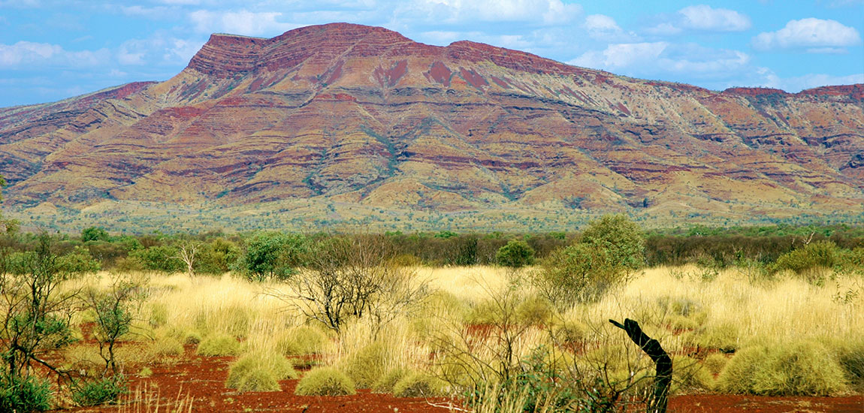

**CIVIL CONSTRUCTION- INDIGENOUS ENGAGEMENT- PROJECT MANAGEMENT**

**Our Systems**

Lorrex’s systems are aligned to ISO standards of Safety, Environment and Quality. Working to these international standards ensures all activities are performed in a systematic and controlled manner. We take care to ensure work is performed by appropriately qualified staff and contractors.

Every Lorrex project has pre-determined key performance indicators to ensure the work we

deliver is aligned with client requirements and assessed at regular intervals throughout the project.

By implementing this system at every project site, we can ensure our principles of excellence is

always upheld.

**Directors**

**Rex Parker – Director**

I am an elder of the Banyjima people, born and raised in the Pilbara. My mother was a Nyiyaparli woman and my father a Banyjima man. I began my schooling in Onslow after leaving Wittenoom in the 70’s. I began work at Nanutarra Station and continued working there until my early adult years. I pursued my career in contracting with companies such as Henry Walker Elton, McMahons and Rio Tinto (Paraburdoo) to name a few. In 2012, I established Lorrex Civil & Mining working for FMG (Solomon). I continue to live here on my homeland community of Youngaleena, on Banyjima Land.

**Clinton Wolf – Director**

Clinton Wolf is an experienced businessman with a background in construction and native title. Clinton was the founder and former chair of the Indigenous construction company ICRG. He was formerly a director of Azure Capital, one of the country’s most respected financial advisory groups. A former AFL footballer, Clinton was also the CEO of the Pilbara Native Title Service, the CEO of the Yamatji Land and Sea Council and has advised various mining and exploration companies such as Kimberley Diamonds, Consolidated Minerals, Rio Tinto, Atlas Iron, Sons of Gwalia and Aquila Resources.



[enquiries@lorrexcontracting.com.au](mailto:info@lorrex.com.au)

Suite 3, 26 Clive Street West Perth WA

Ph: 08 6278 3391

ABN : 15 627 639 338

**CIVIL CONSTRUCTION- INDIGENOUS ENGAGEMENT- PROJECT MANAGEMENT**