Muntulgura Guruma

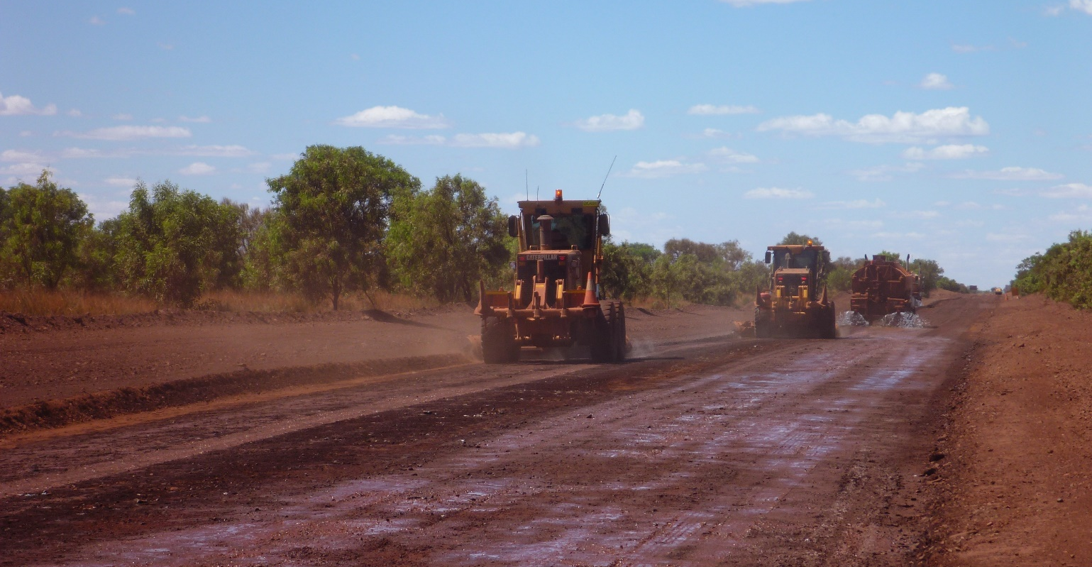
CAPABILITY
STATEMENT

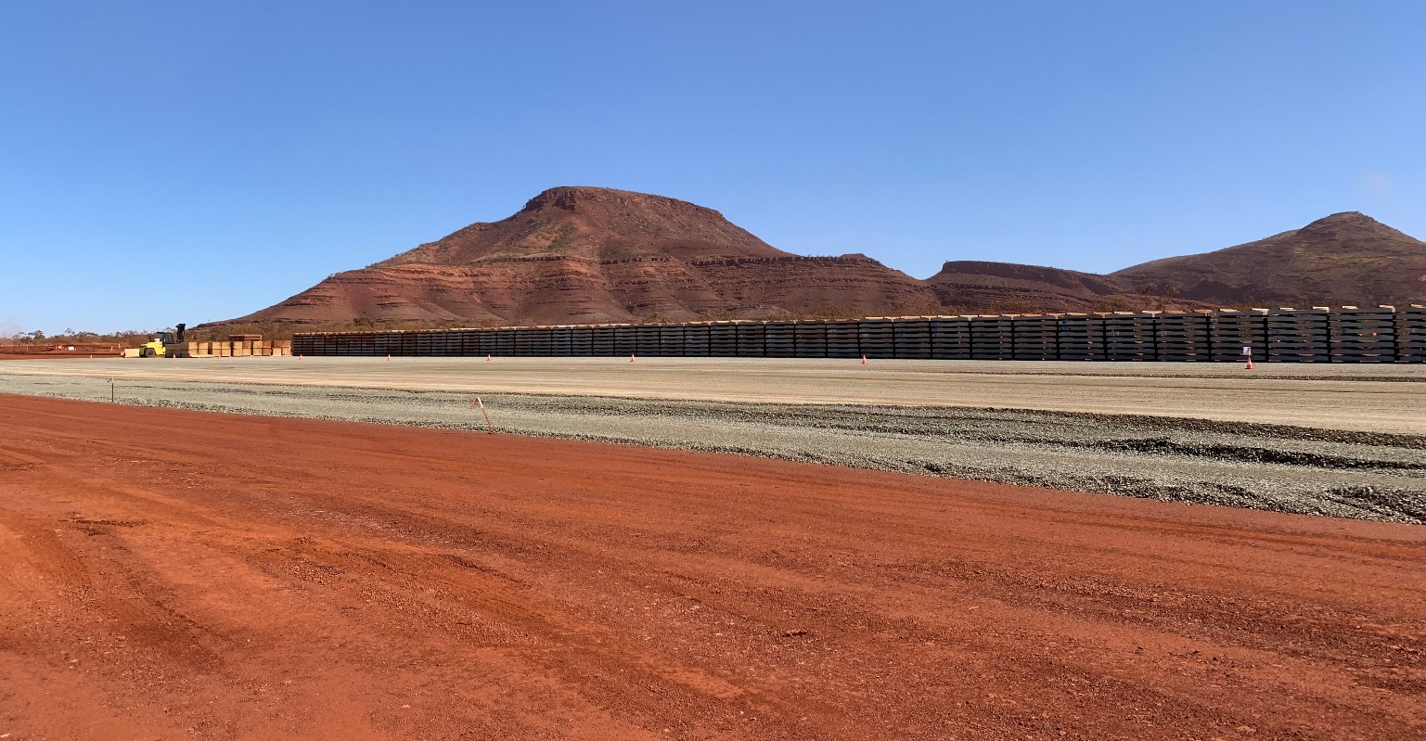

MUNTULGURA
GURUMA

WHO WE ARE
Muntulgura Guruma Pty Ltd (MGPL) is an Indigenous contracting company providing civil and mining services within the Pilbara region of Western Australia. We offer a unique contracting service with the ability to provide a high degree of local Indigenous content.

The company is a 50/50 partnership between iContracting Pty Ltd (iContracting) and HHF Pty Ltd (a company set up to pursue business interest of the Eastern Guruma Hughes and Hicks families).

Eastern Guruma country covers 6,500 square kilometres around Tom Price and Karijini National Park in the Eastern Pilbara region of Western Australia, and includes mine sites such as FMG Solomon, RTIO Greater Brockman mines, and RTIO Tom Price.
Works undertaken by MGPL will involve employment of Eastern Guruma people and the utilisation local employees and subcontractors wherever possible.
WHAT WE DO

MGPL has built a reputation for delivering work of a high standard, on time and on budget. We build work teams that are responsive, flexible, well trained and are supported by the project management and engineering experience of our management group.

Access to our extensive plant list provides further cost and scheduling efficiencies to our clients.

MGPL aims to provide a diverse range of services to both private and government clients. We partner with our clients to safely, sustainably and reliably deliver projects as required. MGPL’s capability includes:
MINING SERVICES
>> | Mine rehabilitation
>> | Plant clean-up crew
>> | ROM Plant waste
>> | Wet hire plant
>> | Dry hire plant
>> | Labour hire
>> | Rehabilitation works
>> | Miscellaneous site earthworks

CIVIL WORKS
>> | Road construction
>> | Road maintenance
>> | Detailed earthworks
>> | Bulk earthworks
>> | Water infrastructure
>> | Drainage
>> | Pre-strip / topsoil removal
>> | Fixed plant clean-up / general site works
>> | Fencing, gardening, waste removal.

MUNTULGURA
GURUMA

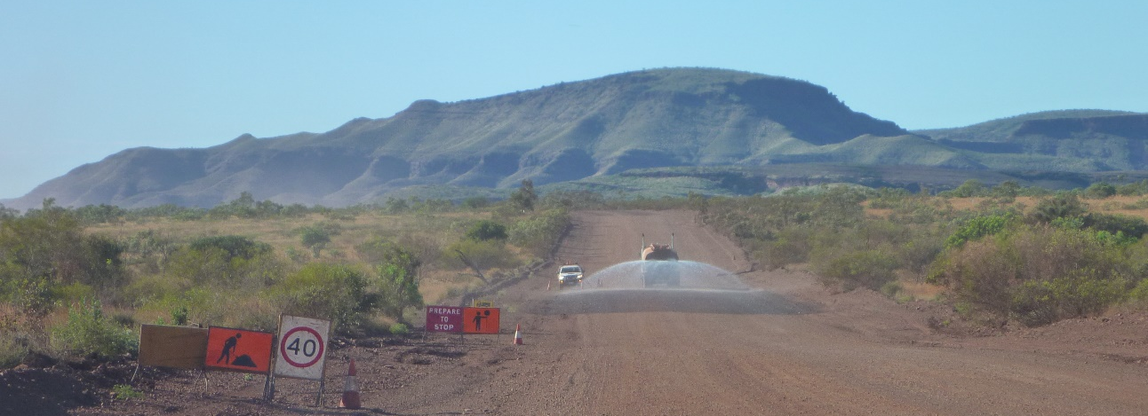
OUR PEOPLE

The management team of MGPL has a proven track record of delivering projects safety, on-time and on-budget. The team has significant expertise in civil construction, road maintenance, mining services and project management along with locally based Directors with on-the-ground knowledge and community links. This combination of skills provides clients with a high-quality contracting service with the ability to provide effective local Indigenous engagement.

MGPL recognises that our people are our most important resource. To build a committed, stable and positive workforce we focus on providing attractive career development opportunitiies, comprehensive training and culturally appropriate support.

MGPL is an equal opportunity employer that actively encourages positive recruitment initiatives to improve Indigenous participation at all levels.

OUR PROJECTS

MGPL is focused on building capabilities for Pilbara Indigenous people utilising its existing capability, allowing local people to make the most of the opportunities presented by projects operating in their area. Project involvement include:

- FMG Solomon: Nanutarra Rd – long term Maintenance works
- FMG Solomon : Train Load Out Maintenance operations
- FMG Eliwana Rail : Ballast Pad, Sleeper Pad and Camp Pad Construction
- FMG Eliwana Rail : Long term misc. Construction & Maintenance works

Muntulgura Guruma

OUR SYSTEMS

MGPL’s systems are aligned to ISO standards of Safety, Environment and Quality. Working to these international standards ensures all activities are performed in a systematic and controlled manner.

We take care to ensure work is performed by appropriately qualified staff and contractors. Every project has pre-determined key performance indicators to ensure the work we deliver is aligned with our client.

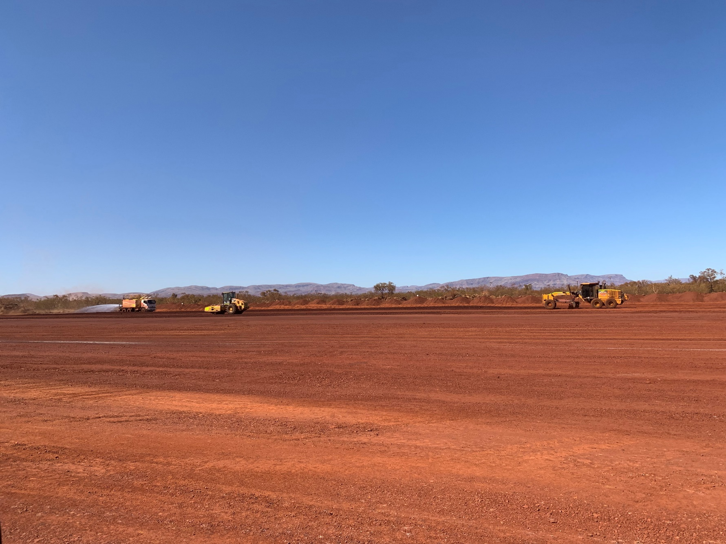

CONTACT US

E: enquiries@mgjv.com.au
P: 08 6278 3391
A: Unit 3, 26 Clive Street, WEST PERTH WA 6005

